**Geophysics 457**

**Assignment 2**

Safian Omar Qureshi

ID 10086638

1.

2. From looking at the first plot, we can see three distinct slopes. These three distinct slopes represent the 3 different mediums since velocity between medium changes, and since it is 3 different mediums there is 3 slopes, hence there is 3 layers.

------

3. The velocity of a layer is simply the reciprocal of the slope. Thus for the first layer, it is 1/0.0026683684 = 374.8m/s = v0.

For layer 2 it is 1/0.0002738476 = 3651.7 m/s = v1.

For layer 3 it is 1/0.0002249667 = 4445.1 m/s = v2.

------

4. The thickness for layer 1 would be represented by the formula;

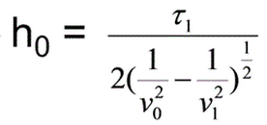

Where t1 is the y intercept of the line in the second graph on page 2. Thus;

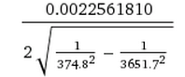

Which gives us 0.425053 m for layer 1 thickness.

Layer 2 thickness would be represented by;

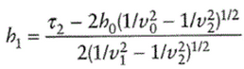

And so plugging in values would give us;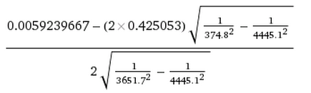

Which results in 11.7324 m

Layer 3 doesn’t really have a thickness/infinite because of it being halfspace region.

------

5. To find density for layers, we use Gardener’s Relation:

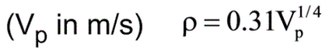

So for layer 1 we have: p = 0.31(374.80m/s)^(1/4) = 1.36 g/cm^3

For layer 2 we have: p = 0.31(3651.7m/s)^(1/4) = 2.41g/cm^3

For layer 3 we have: p = 0.31(4445.1m/s)^(1/4) = 2.53g/cm^3

------

5. We can use the following equation to find v, poisons ratio, where Vs is Vp/1.7

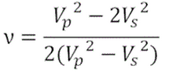

Thus for layer 1:

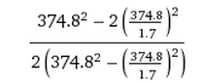

Which results in 0.2354 = v. Other layers can be found with same equation

6.

**Table Compiling All Data**

|  |  |  |  |  |
| --- | --- | --- | --- | --- |
| Layer # | Velocity (m/s) | Thickness (m) | Density (g/cm^3) | Poisson Ratio |
| 1 | 374.8 | 0.455053 | 1.364 | 0.2354 |
| 2 | 3651.7 | 11.7324 | 2.41 | 0.2354 |
| 3 | 4445.1 | - | 2.53 | 0.2354 |